https://github.com/MicrosoftLearning/MB-310-Microsoft-Dynamics-365-Finance/tree/master

lab
title | module
Lab 1: Bank foreign currency revaluation | Learning Path 01: Set up and configure financial management; work with General Ledger

MB-310: Microsoft Dynamics 365 Financial Consultant
Change Record
Version | Date | Change
1.0 | 13 Sep 2024 | Initial release
Objective
Lab 1 Bank foreign currency revaluation
As part of a period end, accounting conventions require bank account balances in foreign currencies to be revalued by using different exchange rate types (current, historical, average, and so on). With the bank foreign currency revaluation feature, you can revalue one or more bank accounts. Because it’s a global feature, you can revalue banks across all legal entities you have access to from a single page.
Use the USMF company for the exercises in this lab.
Exercise 1 Create a transaction that can be revalued
During this lab, you will first enter a transaction in a bank journal that can be revalued. The second step is to prepare foreign currency revaluation. After you configure the foreign currency revaluation, you run the process and then review the results.
Scenario
Contoso, Ltd. has a new financial controller who plans to run a foreign currency revaluation of bank account USMF EUR as part of the period end. To test the process, the financial controller first creates a general journal with a transaction that can be revalued.
- In the USMF company, navigate to General Ledger > Journal entries > General journals.
- Select the New button to create a new journal. 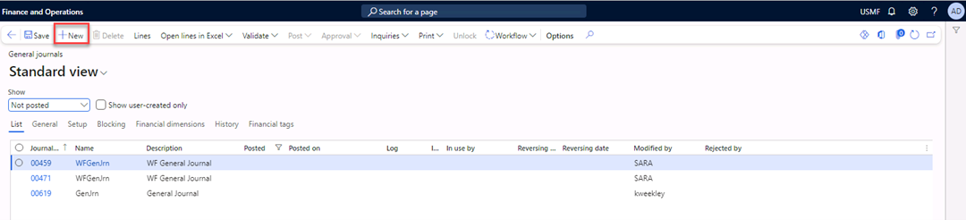
- Select GenJrn in the Name field. 
- Select the Lines button in the Action Pane. 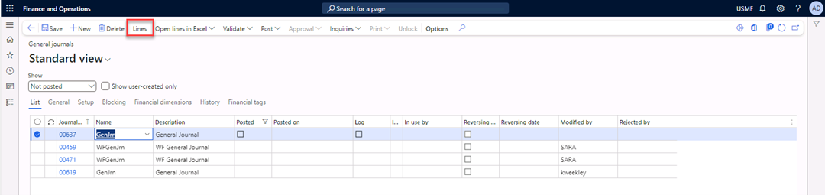
- In the Date field, enter 7/1/2024.
- In the Account field, select 600155 for the MainAccount, 001 for the BusinessUnit, and 022 for the Department.
- In the Debit field, enter 1,000.00.
- In the Offset account type field, select Bank.
- In the Offset account field, select USMF EUR. 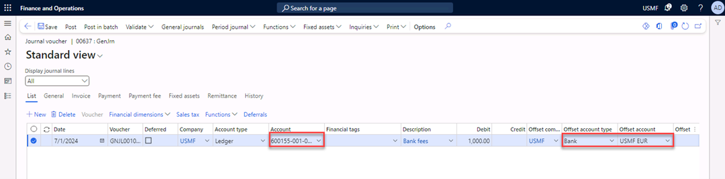
- In the Currency field, select EUR. 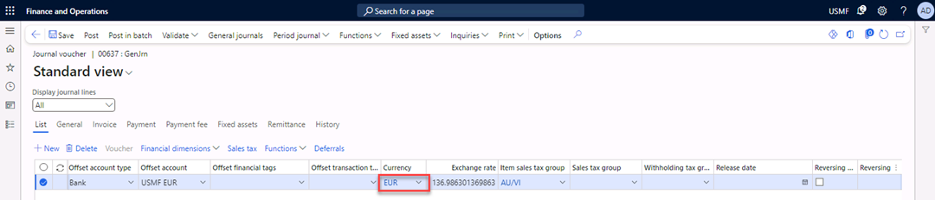
- Select Post in the Action Pane to post the journal. 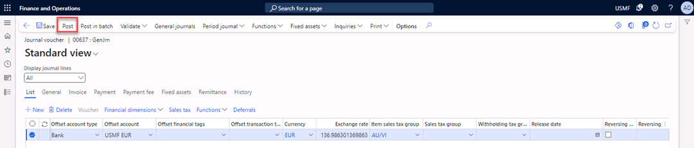
- Close the form.
Information: Prepare the foreign currency revaluation
Note: This is for informational purposes only; the configuration is already done in USMF.
- In the USMF company, navigate to General Ledger > Ledger setup > Ledger, and then expand the Currency tab.
- In the Accounting currency exchange rate type field, display the Default value.
- Select Accounts for currency revaluation.
- Review the values for realized gain, realized loss, unrealized gain, and unrealized loss accounts for the currency revaluation. 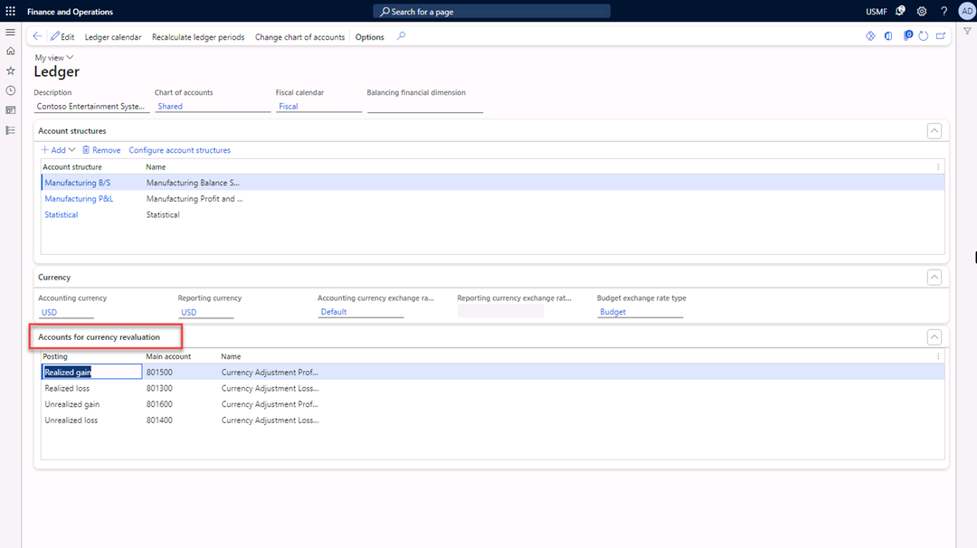
- Navigate to Cash and Bank management > Setup > Cash and bank management parameters.
- Select the Number sequence tab.
- Review the number sequence for Foreign currency revaluation. 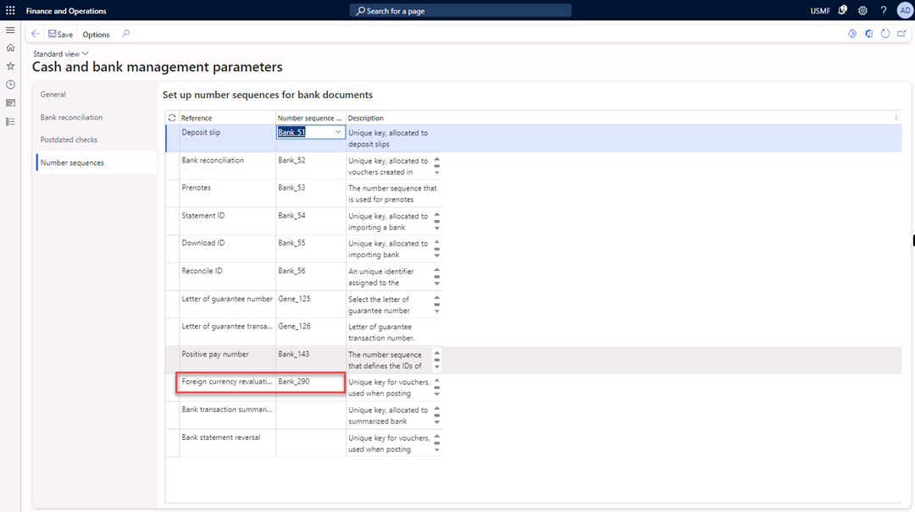
Exercise 2 Update currency exchange rate
- Navigate to General ledger > Currencies > Currency exchange rates.
- In the Exchange rate type list, select Default.
- Select the line with USD in the From currency field and EUR in the To currency.
- Select Add to enter a new exchange rate. 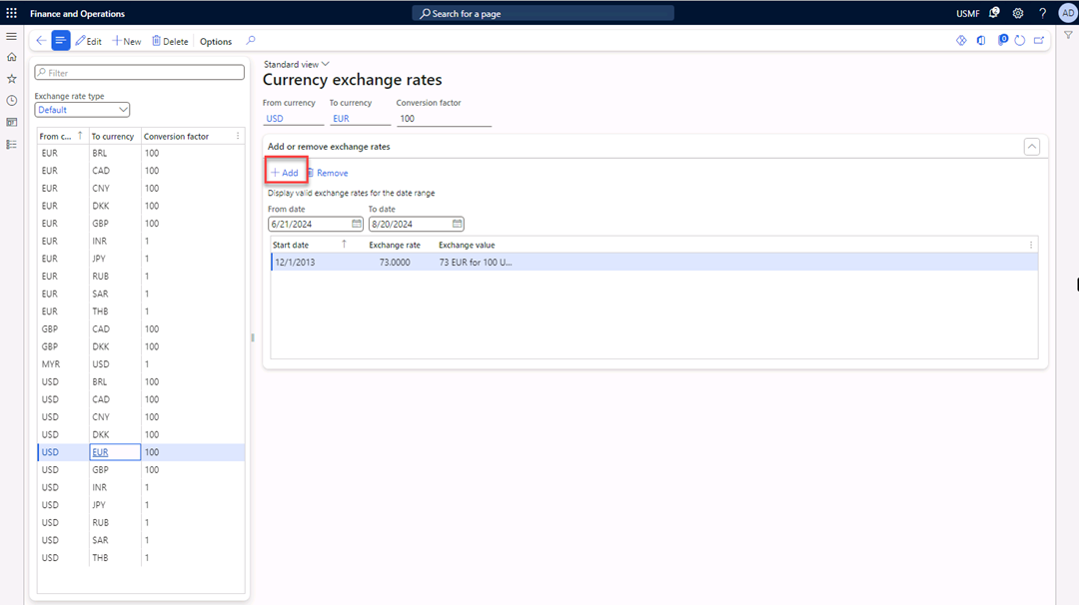
- In the Start date field, enter 7/15/2024.
- In the Exchange rate field, enter 91.8000. 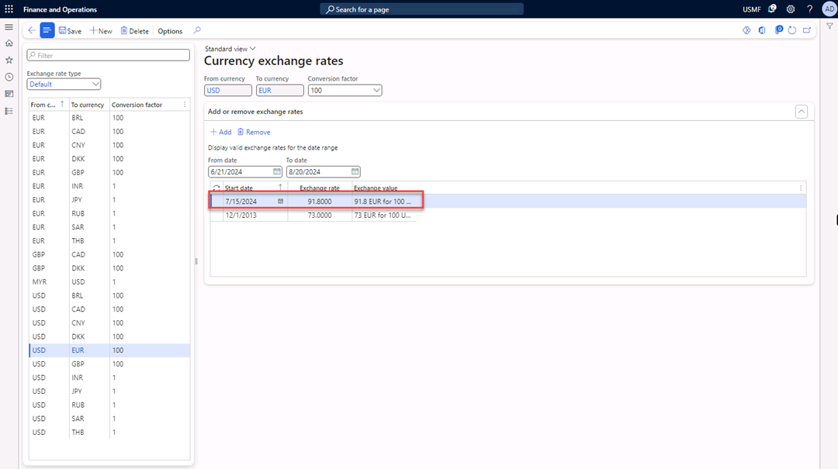
- Select Save in the Action Pane.
- Close the form.
Exercise 3 Execute the foreign currency revaluation
- Navigate to General Ledger > Currencies > Foreign currency revaluation.
- Select the Foreign currency revaluation button in the Action Pane. 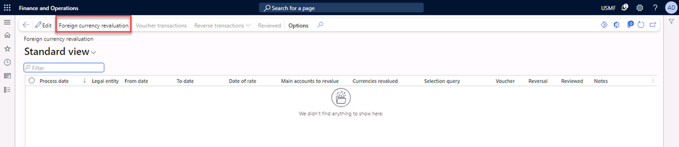
- In the From date field, enter 7/1/2024.
- In the To date field, enter 7/31/2024.
- In the Date of rate field, enter 7/21/2024.
- In the Currencies to revalue list, select EUR.
- Switch Preview before posting to Yes.
- Select Filter. 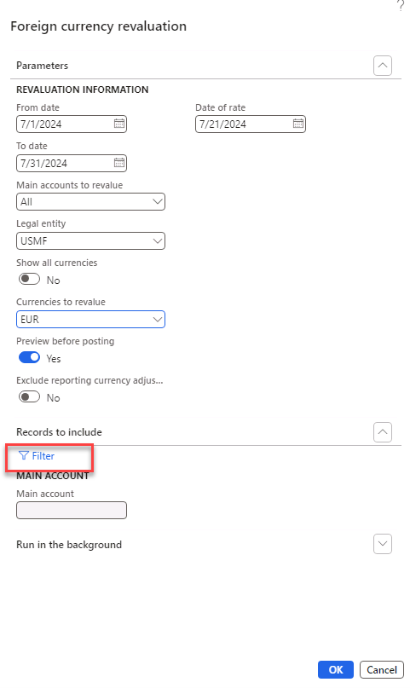
- In the Criteria field, select the Main account 110130. 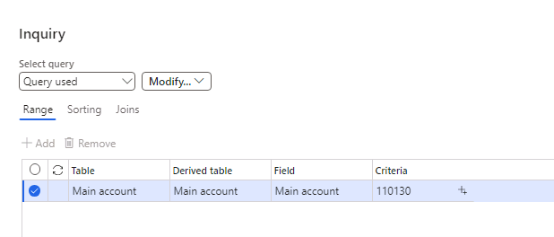
- Select OK and OK.
The message “Operation completed” appears in the message bar. 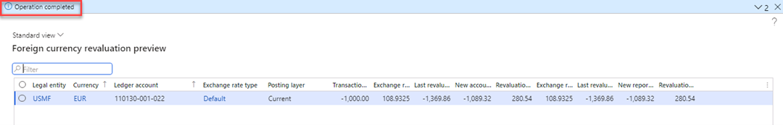
Calculation
Date | Currency EUR-100USD | Currency 1 EUR – USD | Currency 1,000 EUR - USD
12/1/2013 | 73 EUR = 100 USD | 1 EUR = (1 / 0.73) 1.36986 USD | 1000 EUR = (1000 * 1.36986) = 1,369.86 USD
7/15/2024 | 91.80 EUR = 100 USD | 1 EUR = (1 / 0.9180) 1.08932 USD | 1000 EUR = (1000 * 1.08932) = 1.089,32 USD
Today’s date |  | Exchange rate gain | Revalued amount = 1,089.32 USD – 1,369.86 USD = 280.54 USD
- Post the journal. 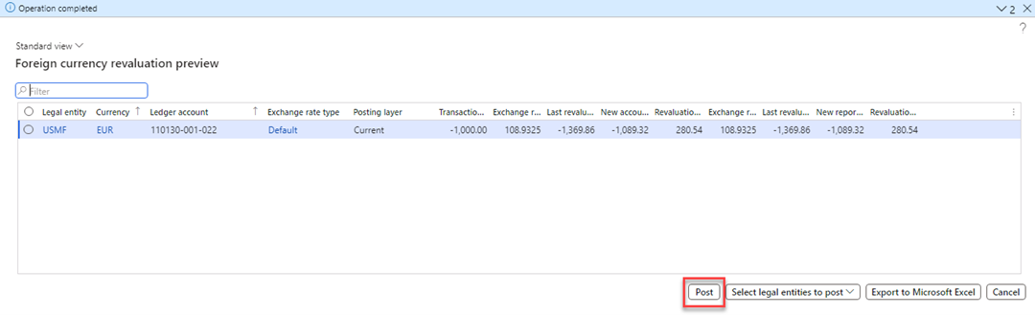
Exercise 4 Review the voucher and balance of the foreign currency bank account
- Select the Voucher transactions button in the Action Pane. 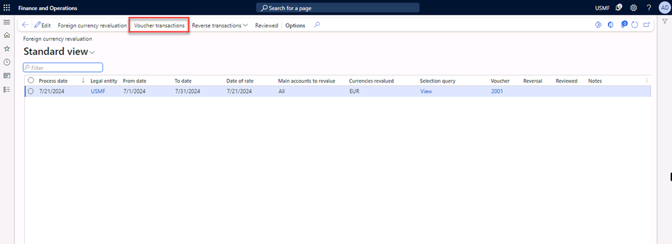
- Review the voucher transactions. 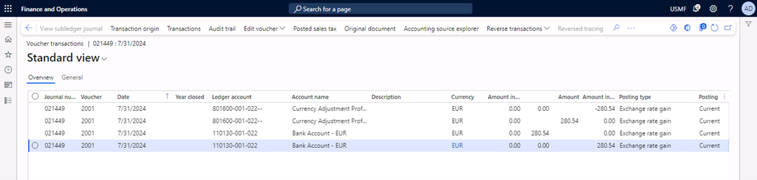
The currency EUR has decreased, which is an exchange rate gain for USMF.
- Navigate to General ledger > Inquiries and reports > Trial balance.
- In the From date field, enter 1/1/2024.
- In the To date field, enter 12/31/2024.
- Select Calculate balances. 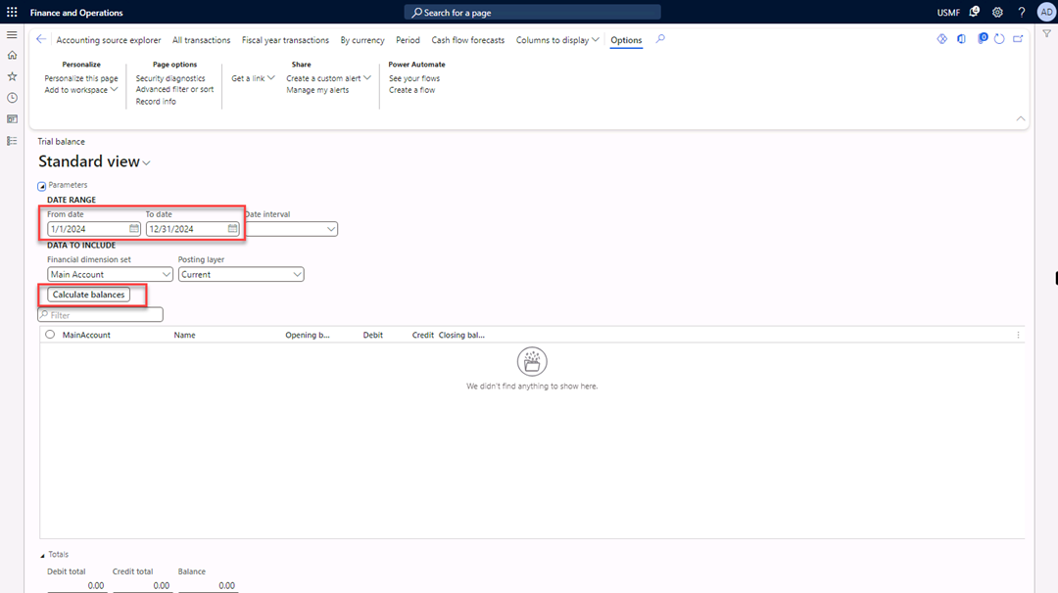
- View the balance of main account 110310. 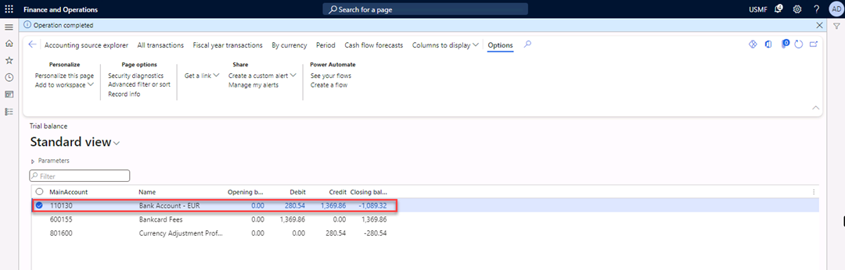
- Close the form.

